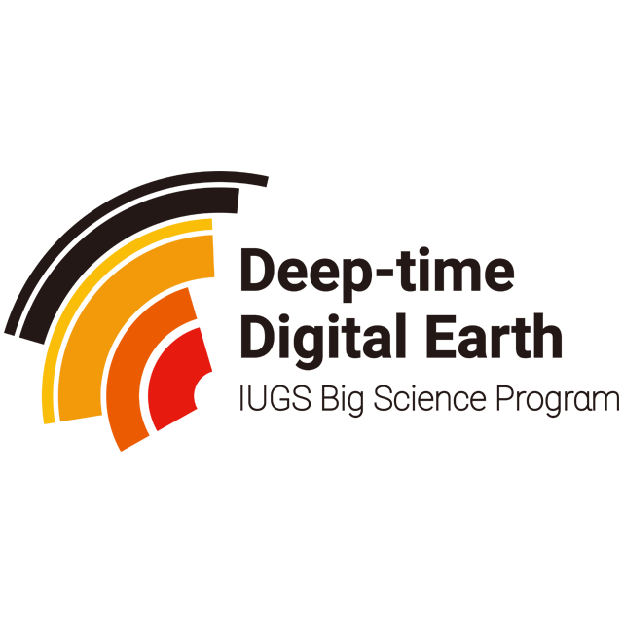

DEEP TIME DIGITAL EARTH PROGRAM (DDE)
Annual Report of DDE________Group

Duration: 2021-2022
__________________________________________________________________________________
Group Leader & Co-leader(s):

___________________________________________________________________________
Group Members:

___________________________________________________________________________
Date of submission:

Signature of the group leader:
Guidelines for Annual Report
（March 2022)
Please use the following guidelines to report the work progress last year, work plan for this year, related scientific achievements and funding requested (write N/A where not applicable). The report submitted to DDE will be an important basis for funding allocation.
- Website address(s) related to the group
- Summary of major achievements obtained last year
2.1 List of countries involved in the group
2.2 List of general scientific achievements conductive to DDE’s development
2.3 List of meetings/symposium/workshop hosted by the group
2.4 List of meetings/symposium/workshop group members participated
2.5 Educational, training or capacity building activities
2.6 Participation of female scientists, young scientists and scientists from developing countries
2.7 List of most important publications, including maps (Distinguish between peer review literature and other bibliography)
2.8 Activities involving/involved with other DDE branches, IUGS, IGCP, ILP or others
3. Contributions and support to DDE MTP (Medium Term Plan) objectives and associated deliverable during 2021-2022
3.1 Construction of DDE Cyber-infrastructure (design and testing of DDE Platform; DDE Big Data integration & sharing; Standards & specifications for data; AI, machine learning, reconstructed geoscience knowledge; Integrated communication strategy & standards, etc.)
3.2 Enriching ddeworld.org website construction
3.3 Securing DDE’s financially sustainability through agreements and partnerships
4. Work Plan
4.1 General goals and expected results
4.2 Tentative list of specific meetings/conferences/activities with participating countries
4.3 Group Communication
4.4 Construction of the group website and contributions to the DDE website
4.5 Scientific Legacy
- Group funding requested (for this year)
$ 10,000
$ 5, 000

- Financial Statement (in USD only)

- Any relevant information

