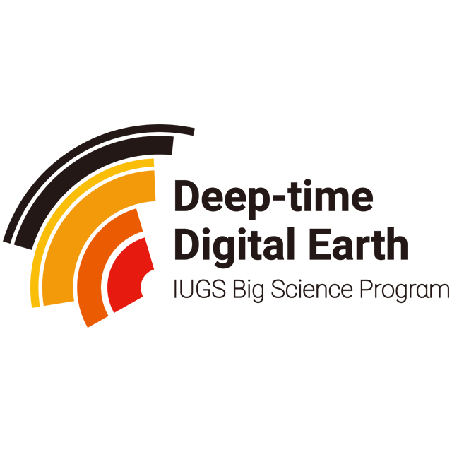

DEEP TIME DIGITAL EARTH PROGRAM (DDE)
EVALUATION FORM

FOR DDE WTG ANNUAL FUND APPLICATION
FOR FUND APPLICATION OF DDE WTG ONLY

Duration: ________ year submission for ________ year start

Following the 6th Executive Committee meeting of DDE, Prof. Mikhail Fendonkin was appointed to lead the establishment of an evaluation board to review the annual work progress of the DDE Working and Task Groups and decide on the financial support for the next fiscal year (December of the previous year to December of the next year)
Evaluation Score
5 | Outstanding - indicates to a breakthrough progress of the work
4 | Good - indicates to a great progress of the work
3 | Fair - indicates to the achievement of the set goal
2 | Low - indicates to the poor achievement of the set goal
1 | Poor - Failure to achieve the set goal

CATEGORY A: The total score is in the top 20% of all groups (1st - 5th )
CATEGORY B: The total score is in the top 70% of all groups (6th - 24th )
CATEGORY C: The total score is in the bottom 10% of all groups (24th - 26th )

Deep-time Digital Earth Evaluation Board, Executive Committee
Evaluation Form of the DDE_________________ working☐/task☐ group
Year:____________

Group Leader:
Group co-leader(s):

Relevant missions for WTGs to be used as a refer (adopted on the 3rd WTG Meeting, May 2021)
Main Mission (for WG)  Select only one | - Infrastructure building☐  - Database design☐  - Data quality control☐  - Research promotion☐  - Others☐
Main Mission (if this is a TG)  Select only one | - Harmonize regional geological databases☐  - Create tools, method or standards to harmonize or analyze data☐  - Popular science, education, and communication☐  - Others☐

Is this group newly established in this year? | Yes☐  No☐ | Notes:
Has this group received fund from DDE in the last fiscal year? | Yes☐  No☐ | Notes:
Does this group have any unused funds? | Yes☐  No☐ | Notes:

SECTION 1: Equality and Diversity
Equality/Diversity of the group leader & co-leader(s) team  Affiliation, country, gender, age, etc | Comments: | Score:
Equality/Diversity of the group members  Participation of developing countries, female scientists, young scientists, etc | Comments: | Score:
ToTAL SCORE OF SCETION 1：

SECTION 2: Website construction of the group
Richness of the website content  News, reports, videos, photos, etc | Comments: | Score:
Update frequency  Is there a fixed update frequency? Is there a dedicated website editor? | Comments: | Score:
Website Visibility  Link with social media, other scientific websites;Visits per month | Comments: | Score:
ToTAL SCORE OF SCETION 2：

SECTION 3: Major achievements obtained last year
Countries involved in the group  Special attention to African countries and developing countries | Comments: | Score:
General scientific achievements conductive to DDE’s development  Contributions to raise the profile of DDE, affiliated to the Mission and Vision, MTP (Medium Term Plan) of DDE | Comments: | Score:
Meetings hosted by the group  Frequency, quality of the meetings | Comments: | Score:
Meetings that group members participated  Special attention to the influential international academic meetings/symposiums/workshops | Comments: | Score:
Educational, training or capacity building activities  links with external young scientists and other DDE WTGs | Comments: | Score:
Publications  Have a great impact in expanding the influence of DDE in the academic community | Comments: | Score:
Activities with other DDE branches, IUGS, ISC, etc.  Collaboration, cooperation either internally or externally | Comments: | Score:
ToTAL SCORE OF SCETION 3：

SECTION 4: Contributions and support to DDE Medium Term Plan
Construction of DDE Cyber-infrastructure  Design and testing of DDE Platform, databases, creation of new tools, etc. | Comments: | Score:
Enriching DDE website  Regular provision of content to ddeworld website,linking member/partner websites to ddeworld, etc | Comments: | Score:
Securing DDE’s financially sustainability through agreements and partnerships  Make rational use of the funds allocated by DDE and attract more external funds | Comments: | Score:
ToTAL SCORE OF SCETION 4：

SECTION 5: Work Plan
General goals and expected outcomes  Rationality and enforceability of setting goals | Comments: | Score:
Future meetings/conferences/activities  Identify the future collaboration with other DDE groups, other IUGS organizations or activities, etc | Comments: | Score:
Group communication  Identify plans for future scientific publications | Comments: | Score:
Construction of the group website and contributions to the DDE website  Ongoing construction, maintenance, updates of the group’s website;Identify specific member of the group to provide materials for enriching DDE website frequently | Comments: | Score:
Scientific Legacy  The storage of publications, files, data or other vital materials generated by the group. Who will be the custodian? Where the data would be stored? | Comments: | Score:
ToTAL SCORE OF SCETION 5：

SECTION 1 | SECTION 2 | SECTION 3 | SECTION 4 | SECTION 5
TOTAL SCORE:

FUNDING RECOMMENDATIONS ON THE BASIS OF THE ABOVE SCORE:
Select one only
1. The group should be financially supported with 10,000 USD in this fiscal year☐
2. The group should be financially supported with 5,000 USD in this fiscal year☐
3. The group should be revised and resubmitted the report next year based on comments below☐
4. The group should not be financially supported☐
5. The group’s work is not eligible for DDE mission and vision☐
General Comments from the Evaluation Board:

Date:

