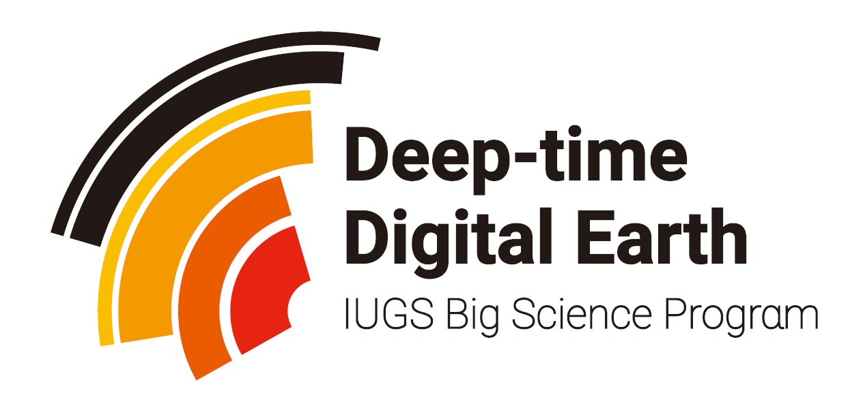

DDE PROPOSAL GUIDELINE (2020)

DDE project life-cycle
As the flow diagram (fig.1) shows:
- DDE will develop goals and strategies before allocating resources and making investments, continually collecting and sharing data on our projects progress, reflect on lessons learned, and make course corrections as needed.
- When we know that an organization is well-suited to perform the work, we directly send an invitation letter to the organizations with guidelines and templates.
- when we want to broaden our network for a project, we may issue a request for proposals, which will be posted on DDE website.
- DDE reviews submitted materials with internal and, at times, external experts and works with the applicant to integrate recommended changes until the proposals are approved. It is not unusual for an applicant to be asked to revise the proposal contents and budget details.
- DDE will confirm the applicant organization’s financial status, the legality and conflict of interest of the project content, determine how to structure the transaction, and assess risks.
- Before funded activities can commence, DDE and the applicants sign a contract that includes intended results, targets, milestones or reporting deliverables, and a payment schedule (Usually allocated once every financial year).
- During the life of an investment, DDE and partner discuss how they will work together and keep in close communication to understand progress and challenges of ongoing work. Annual report is required for each project and will be post on DDE official website. The annual report is an important reference for the allocation of funds for the next year.
- At the end of the project, the partner will submit a final report that summarizes the results achieved and lessons learned.

Fig.1 DDE project life cycle diagram

DDE priority support strategy
The Deep-time Digital Earth (DDE) Program (http://www.ddeworld.org/) is the first 'big science program' initiated by the International Union of Geological Sciences (IUGS). This program will provide many new opportunities and directions for the development of the earth sciences. The DDE mission is to harmonize deep-time Earth data, share global geoscience knowledge and facilitate data-driven discovery in the understanding of Earth’s evolution.
This call for proposals seeks to provide seed funding to 3-5 projects in support of data-driven scientific discoveries and interdisciplinary collaboration in the field of earth sciences.

Proposals are gaining priority support from DDE if they:
- Are about to or have already received financial supports from other sources (e.g. other scientific projects or foundations);
- Are able to lead to a significant increase in DDE data volume;
- Are able to lead to significant improvements to the functionality of the DDE platform;
- Focus on global or regional scientific issues that are DDE science goal oriented and big data driven;
- Emphasize interdisciplinary cooperation;
- Are able to carry out activities such as workshops and short courses, especially promoting abilities of early-career scientists or scientists from developing countries;
- Commit to acknowledge the sponsorship of DDE;
- Help DDE to enhance its reputation.
The DDE Scientific Committee, in January 2019, launched a solicitation of opinions on the principle of priority support to the scientific community;
Eight principles were finally established after multiple discussions and votes, which are considered to be in the best interests of applicants and DDE;
DDE is responsible for reviewing all the applications and addressing funding issues.

Tips for writing DDE proposal
- Adhere to the formatting and content requirements laid out in the proposal templates. These requirements are inflexible (If there are many contents to be filled in a column, you can adjust the length of the column; the coversheet of the proposal is not to exceed one page). Proposals not meeting these requirements will not be considered.
- Avoid rhetoric and hyperbole. Illustrate with real instances or examples.
- Be specific about outputs and outcomes. The proposal should explicitly state expected practical, tangible outputs (such as data collected, scientific papers produced, tools developed) and outcomes (such as new knowledge, increased data utilization, web traffic, good reputation, etc).
- Be explicit about the duration of the project (e.g. 1 to 3 years). The maximum duration of a general DDE project is 3 years. Make sure the duration matches the amount of the task, otherwise the proposal may be rejected or reorganized.
- Make constructive use of milestones to the extent applicable (for example, include a schedule of events over time indicating when certain things should be accomplished or happen).
- Letters of support or recommendation are helpful. DDE does not provide template letters or specific suggestions for this.
- Keep proposal compact. A proposal should not come in more than 3 files (such as main proposal, letters of support or recommendation). Draft files should be sent as Microsoft Word files.

